Internet of Things – Project 1
Project Title: Arduino-Based Smart Pet Feeding System Using Grove Sensors

Team Members
- S. Antoinette Joyce – S00291088@atu.ie
- Pearl Fischer – S00285215@atu.ie
- Refilwe Thunywa – S00291055@atu.ie

Links to:
  - Trello Page - Internet Of Things - Arduino Project | Trello
Trello for tasks.

  - GitHub Team Page -Branches · Antoinettejoycee/stepper-code-
GitHub for code and documentation.

Contents
1. Outline of the Problem to be Solve 3
1.1. Background and Context 3
1.2. Problem Definition 3
1.3. Technological Opportunity 3
1.4. Sustainability and SDG Alignment 3
2. Summary of the Project Solution 5
3. List of Project Requirements 7
4. Initial Design 8
4.1. Sketch of Proposed Design 8
4.2. Proposed Code Design 9
4.3. Proposed Hardware Setup 10
4.4. Data Processing Plan 11
5. Description of Data Generated and Storage 12
6. Implementation plan 13
6.1. Data Flow 13
6.2. Parts list 14
7. Testing Approach 15
8. Security Analysis 16
9. Future Enhancements 17
10. References 18

Outline of the Problem to be Solve

Background and Context
The growing integration of the Internet of Things (IoT) into domestic environments has enabled automation through embedded systems, sensors, and network connectivity. Smart home technologies are increasingly applied to pet care, particularly automated feeding systems aimed at improving efficiency, accuracy, and health outcomes.
Manual pet feeding remains common but is inconsistent and dependent on human availability. Research shows that irregular portion control and feeding schedules contribute to obesity and related health complications. The Association for Pet Obesity Prevention (2022) reports that over half of domestic dogs and cats are overweight or obese, increasing risks of diabetes, musculoskeletal disorders, and reduced lifespan (German, 2006).

Problem Definition
Traditional feeding methods rely on manual portion estimation, often resulting in overfeeding or underfeeding. Feeding times may vary due to owner availability, disrupting metabolic stability. Excessive dispensing leads to food wastage, while prolonged exposure increases spoilage risk. Dependence on human intervention reduces reliability and suitability for busy lifestyles. These inefficiencies affect both animal health and household resource management. Environmentally, avoidable food waste contributes to unnecessary resource use and carbon emissions, as highlighted by the Food and Agriculture Organization (2019).

Technological Opportunity
An embedded IoT-based Smart Pet Feeding System addresses these issues through automated scheduling, controlled portion dispensing, and sensor-based monitoring. Real-time clock modules ensure consistent feeding times, while calibrated motor mechanisms enable accurate food distribution. Ultrasonic or load sensors monitor supply levels, and wireless connectivity supports alerts and remote monitoring. Using low-cost microcontrollers and integrated sensors, the system improves precision, reliability, and operational efficiency in domestic pet care.

Sustainability and SDG Alignment
The solution aligns with the United Nations Sustainable Development Goals, particularly SDG 12 (Responsible Consumption and Production) through reduced food waste, SDG 3 (Good Health and Well-Being) through improved dietary management, and SDG 9 (Industry, Innovation and Infrastructure) through practical application of embedded IoT technologies.
Manual pet feeding lacks precision and consistency, leading to health and sustainability concerns. An IoT-enabled automated feeding system offers a feasible embedded solution that enhances health management, reduces waste, and improves household efficiency.

Summary of the Project Solution
The Arduino-based smart pet feeder is a fully automated system designed to streamline pet feeding routines, ensuring both convenience for owners and consistent, healthy nutrition for pets. This system leverages an Arduino microcontroller as the central controller, integrating Grove sensors, actuators, and other hardware components to manage the complete feeding process with precision, reliability, and safety.
The primary function of the system is to dispense controlled portions of pet food according to a pre-set schedule. Feeding times and portion sizes are programmed by the user through push buttons, which act as the primary input interface. The system’s logic ensures that each feeding occurs at the exact scheduled time, reducing the possibility of overfeeding or irregular feeding times, which are common issues in traditional manual feeding. By automating this process, the smart pet feeder minimizes food waste, promotes responsible consumption, and helps maintain the pet’s health.
A key feature of the system is its user feedback and monitoring via the RGB LCD. The display shows the current time using a Real-Time Clock (RTC) and provides system status messages, such as “Feeding in Progress,” “Low Food Level,” or “Manual Feed Activated.” The RGB functionality allows for easy differentiation of messages using color, enhancing the user interface and making it easier for owners to monitor the system at a glance.
Food dispensing is handled by a stepper motor, which provides gentle and precise portion delivery. The stepper motor allows for controlled rotation, ensuring the correct amount of food is released each time. This mechanism prevents sudden or forceful release of food, which could startle the pet or cause spillage. The feeder also includes anti-spillage design features and is mounted securely to maintain structural stability during operation.
Pet presence is detected using the ultrasonic sensor, which monitors the area near the food dish. When a pet approaches within approximately 30 cm of the bowl, a bulb indicator illuminates to signal readiness for feeding. This ensures that food is dispensed only when the pet is present, reducing unnecessary waste and preventing spillage.
Additionally, the system includes a low-volume buzzer for audible alerts. These alerts are triggered during events such as feeding completion, low food levels, or system errors. The combination of visual (RGB LCD and bulb) and audible feedback ensures that both pets and owners are informed about the system’s operation without causing unnecessary noise disturbance.
The feeder’s software is structured around a state-machine architecture, managing operational modes including IDLE, WAITING_FOR_TIME, DISPENSING, and ERROR. This approach ensures smooth and reliable transitions between states, allowing the system to respond to user input, pet presence, or error conditions without interrupting normal operation. Safety features include maximum feeding limits per day, power failure recovery to retain schedules, and stepper motor jam detection. These measures guarantee that the system operates safely, reliably, and with minimal supervision.
The Arduino-based smart pet feeder effectively combines scheduling automation, precise portion control, pet detection, and real-time feedback to deliver a comprehensive solution for responsible pet care. By minimizing food wastage, ensuring consistent feeding routines, and providing clear system status information via the RGB LCD, stepper motor, and ultrasonic sensor, the project demonstrates practical application of embedded system design and automation. The modular design allows for scalability and ease of maintenance, making it suitable for households seeking low-cost, efficient, and sustainable pet care solutions. Through this integration of sensors, actuators, visual displays, and audible alerts, the system represents a robust, user-friendly, and innovative approach to smart pet feeding.

List of Project Requirements
The system should be able to do all the following:
- Dispense food at scheduled times
- Accurate portion control
- Gentle, quiet dispensing
- Display live time on LCD
- Sensor-based control for smart triggering
- Energy-efficient operation
- Design allows future Wi-Fi monitoring

Initial Design

Sketch of Proposed Design
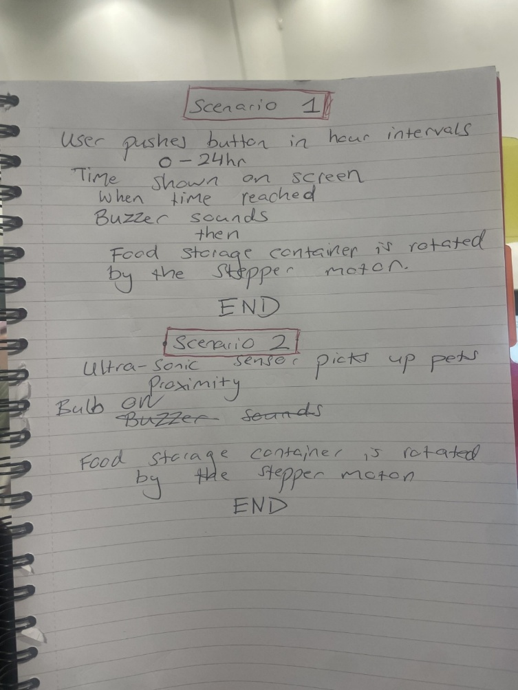
Figure 1: Initial design proposal

This sketch outlines two operation modes for the pet feeder:
- Timed Feeding Mode: Feeding at user-set intervals, with visual time display and buzzer alert, followed by automated food dispensing via stepper motor.
- Pet-Triggered Feeding Mode: Feeding triggered automatically when pet is detected near the bowl, again dispensing food with the stepper motor.
Scenario 1
- User pushes button to set hour intervals (0–24 hrs)
- Time shown on screen
- When time reached:
  - Buzzer sounds (brief)
  - Food storage container is rotated by the stepper motor (to dispense food)
- END
Scenario 2
- When sensor detects pet up next to bowl (pet proximity sensing)
- Food storage container is rotated by the stepper motor
- END

Proposed Code Design via GitHub
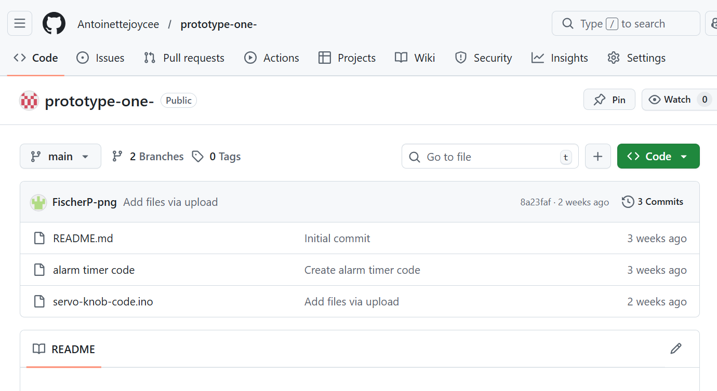
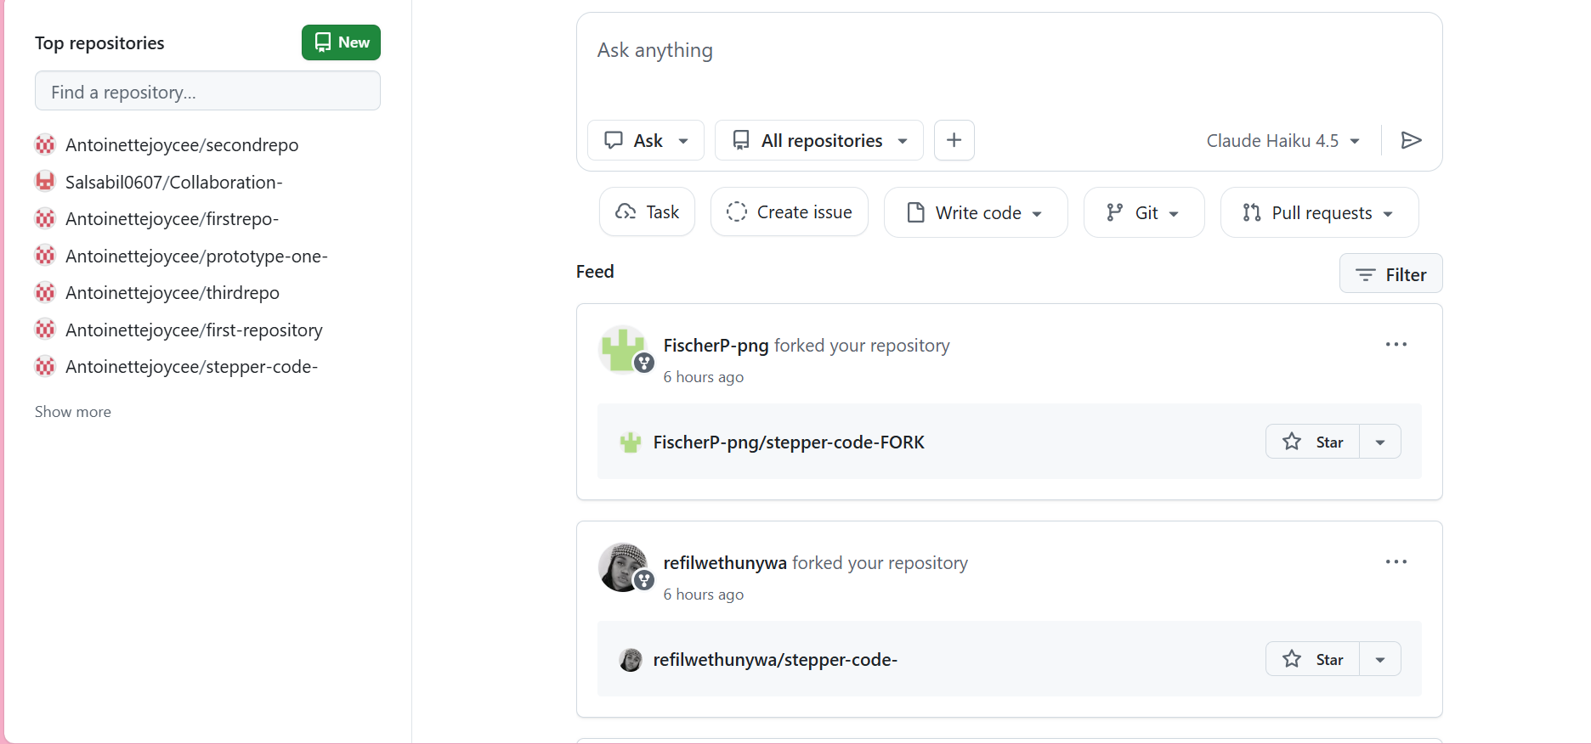
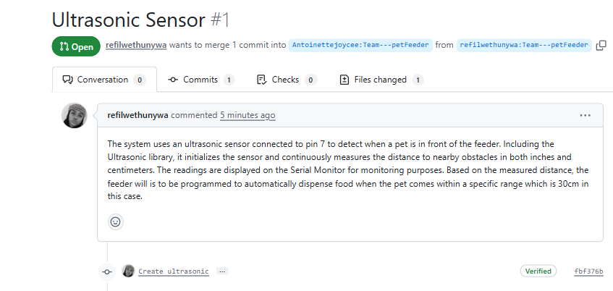

Team brainstorm via Trello
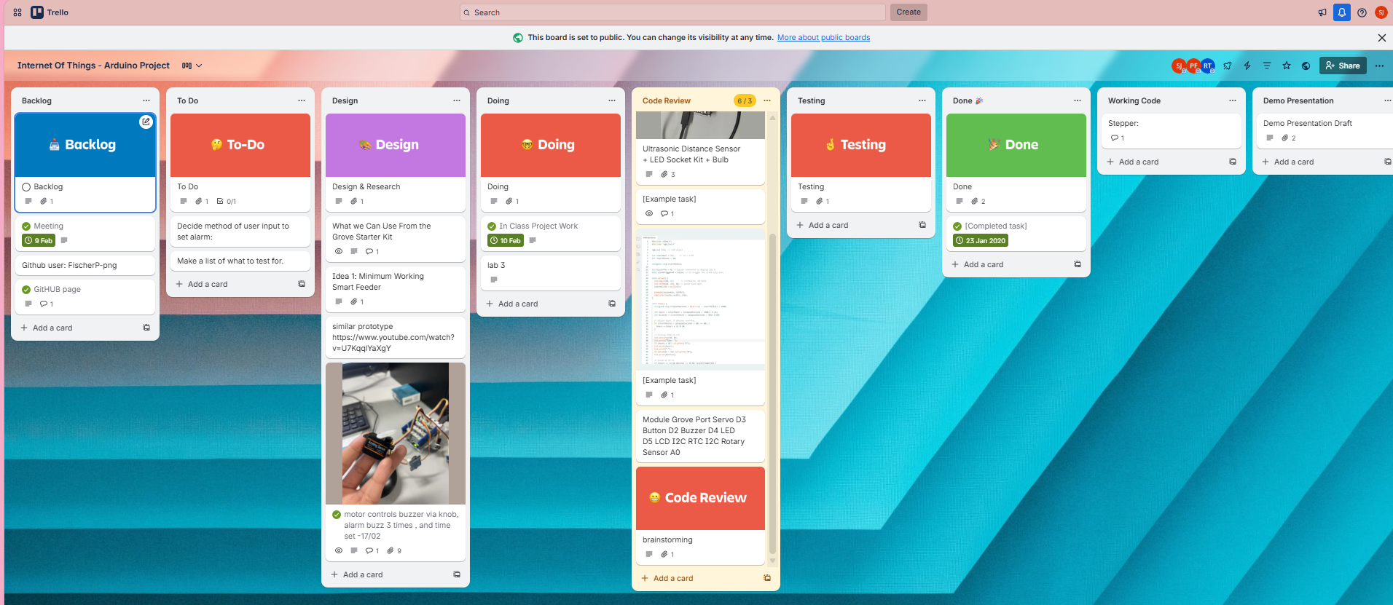

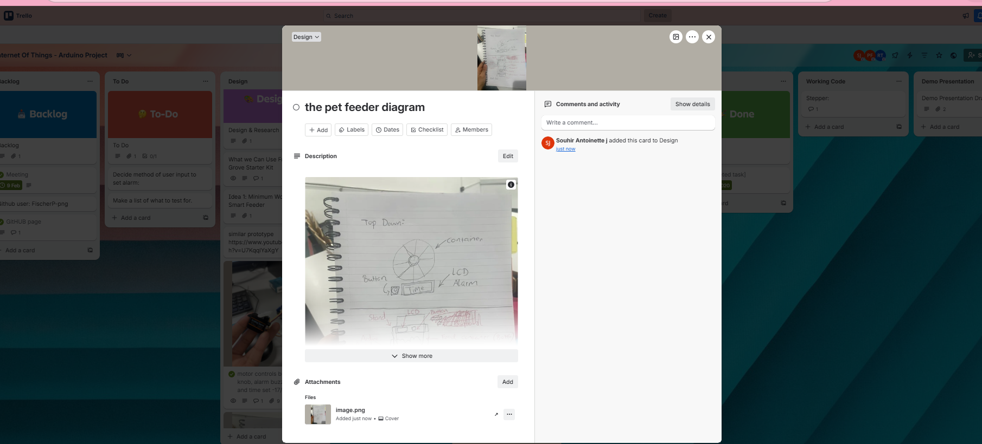

Proposed Hardware Setup
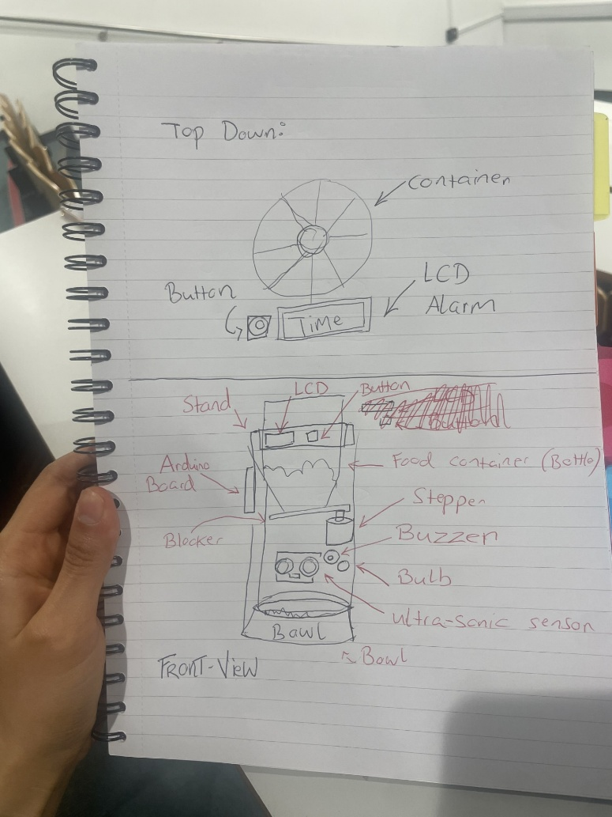
Figure 2: Proposed Hardware Design
Top-Down View
- Container: Circular, divided into portions.
- Button: Next to container for user input.
- LCD: Displays time and status.
- Alarm: Likely buzzer near LCD for alerts.

Front View
- Stand: Device base.
- LCD: Top-front display.
- Button: Near LCD for control.
- Arduino Board: Inside, controls components.
- Food Container: Holds pet food, bottle shaped.
- Blocker: Controls food flow prevents spillage.
- Stepper Motor: Rotates container for dispensing.
- Buzzer: Audible alerts.
- Bulb: Visual indicator.
- Ultrasonic Sensor: Detects pet near bowl.
- Bowl: Collects dispensed food.
The design is compact and functional, with well-placed components: stepper motor for dispensing, ultrasonic sensor for pet detection, accessible LCD and button, and a blocker to manage food flow effectively.

Working Parts Overview.
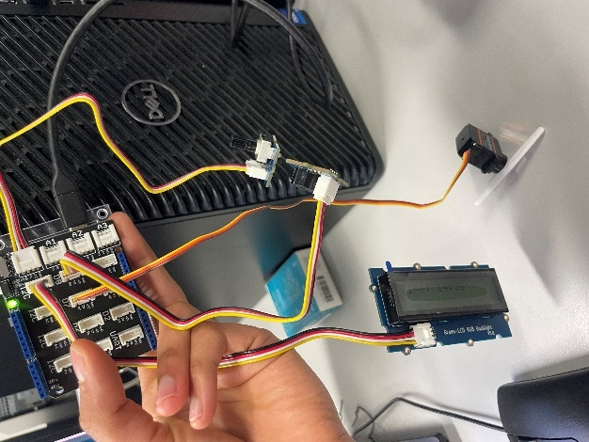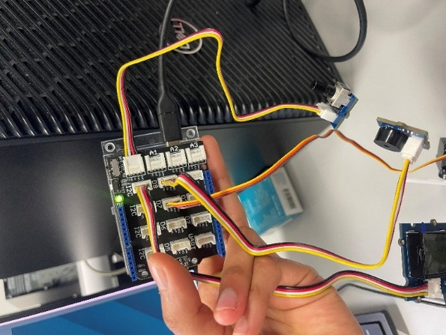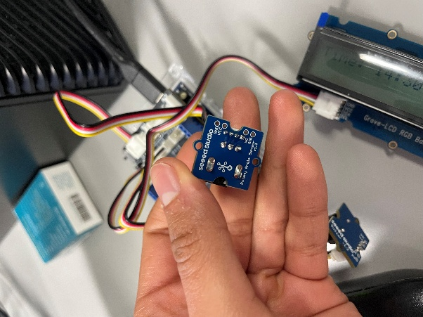

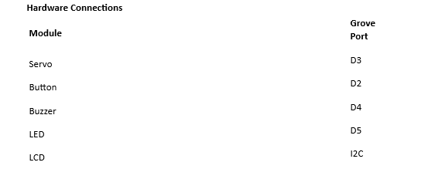
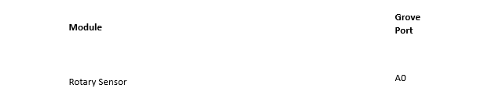
code samples [3 pages + screenshots/photos/diagrams]

Alarm clock Led time display code and comments
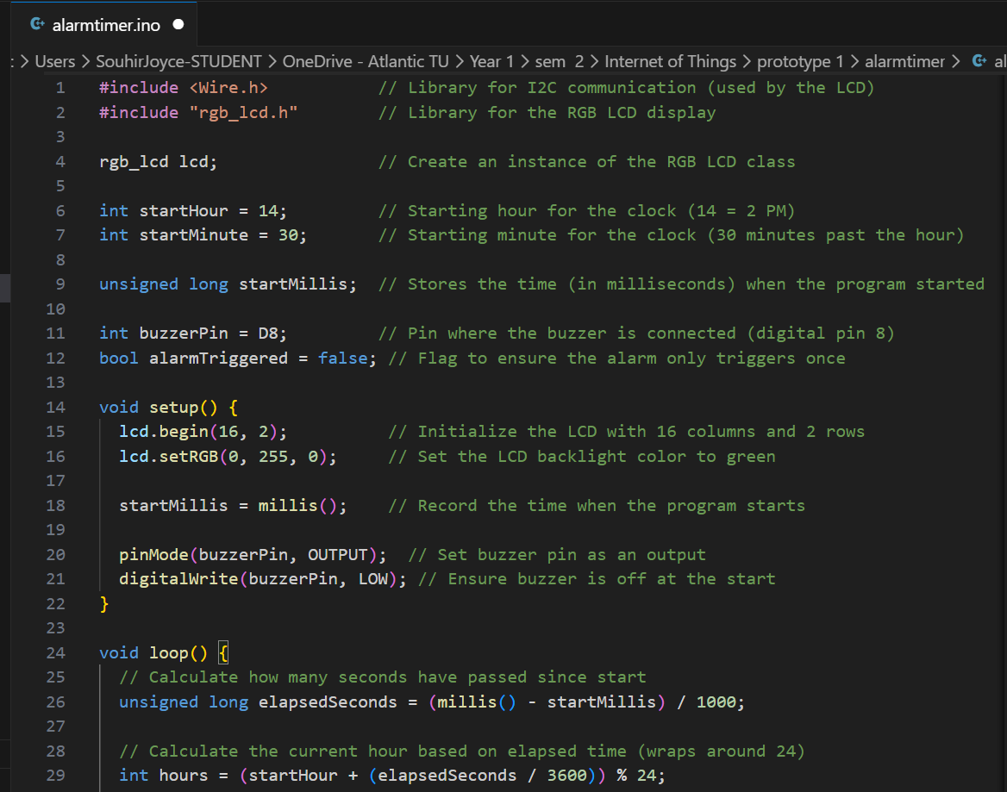

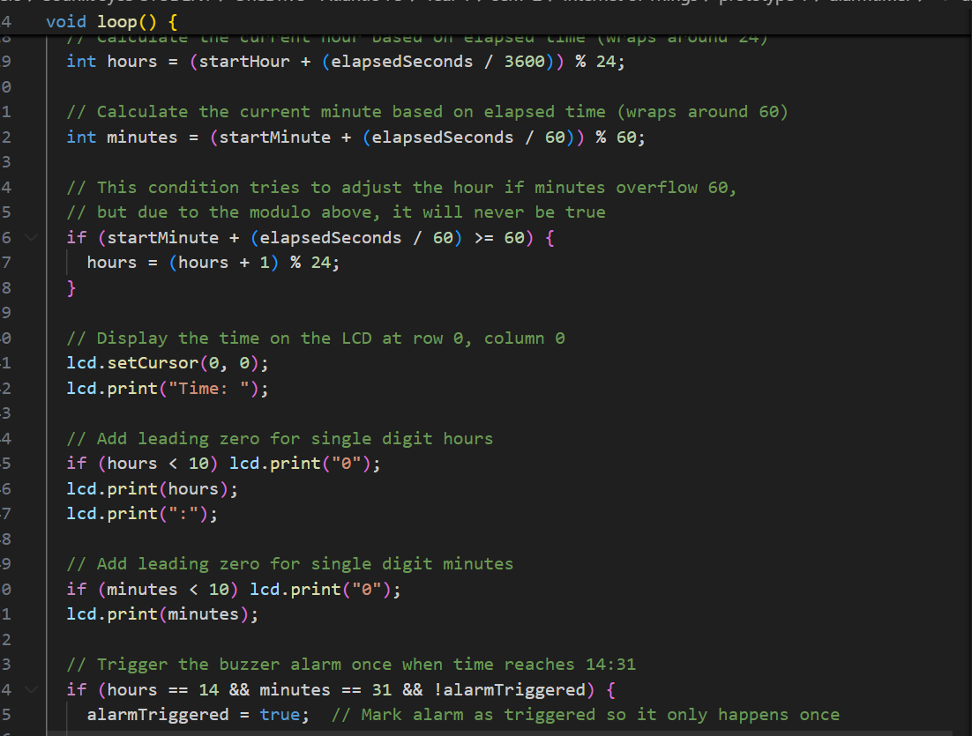
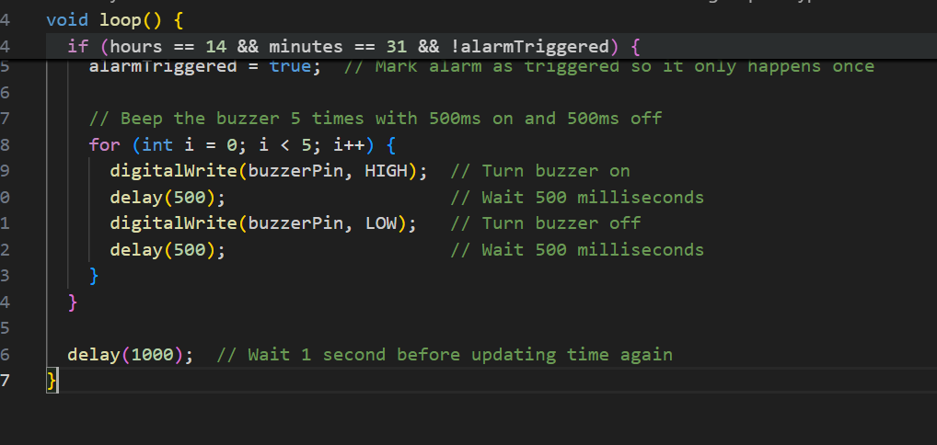

Sensor code
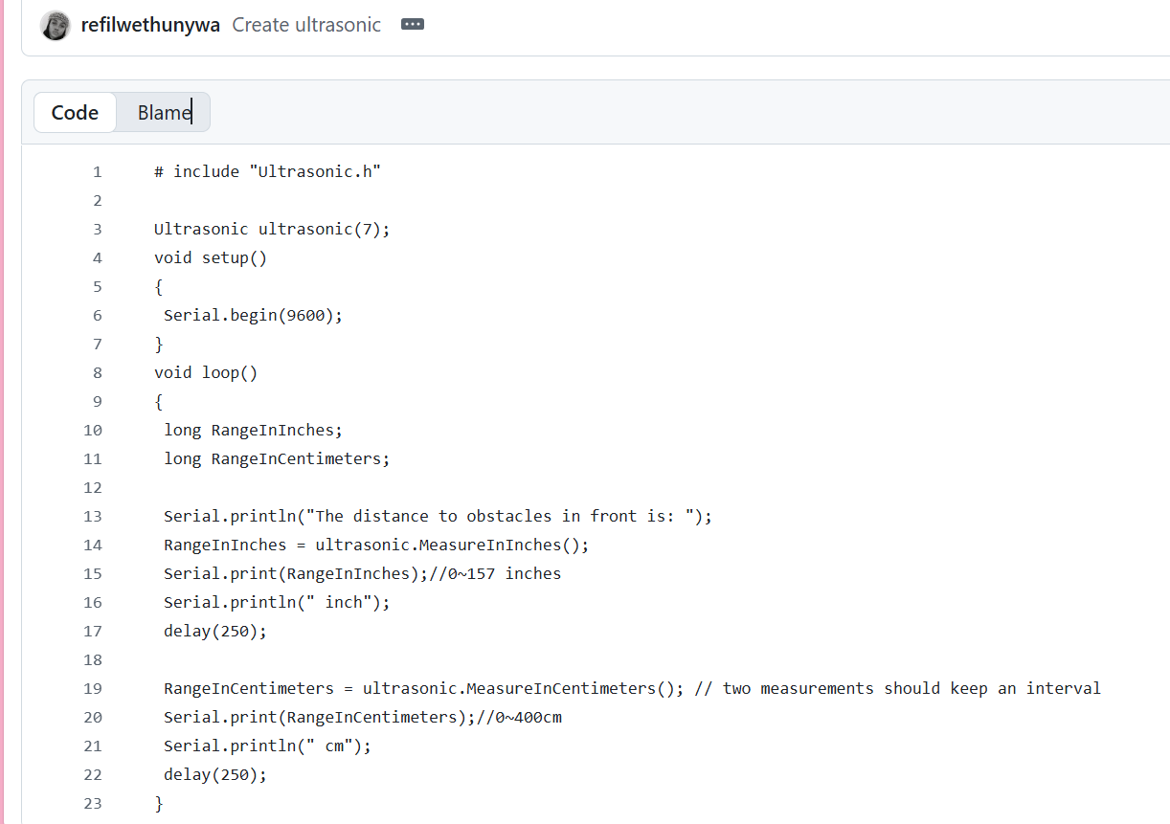

Stepper code

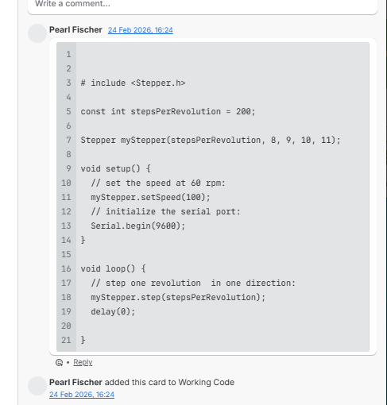

Data Processing Plan
The smart pet feeder uses input from the ultrasonic sensor and real time clock to control feeding.
- Ultrasonic Sensor: Detects the pet within ~30 cm of the bowl; data is filtered to prevent false triggers.
- RTC Module: Provides accurate time to trigger scheduled feedings.
- Control Logic: Arduino uses a state-machine (IDLE, WAITING, DISPENSING, ERROR) to process inputs and manage feeding. Timing uses millis() for non-blocking operation.
- Outputs: Stepper motor dispenses food, RGB LCD shows status, buzzer and bulb provide alerts.
- Data Storage: Feeding schedules and settings are saved in Arduino memory to retain configuration during power loss.
This ensures accurate, reliable, and autonomous operation.

Description of Data Generated and Storage

Data Type | Source / Generation | Use / Processing | Storage / Management
Feeding Schedule Data | User-programmed schedule in Arduino | Determines feeding times and portion sizes | Stored in Arduino EEPROM -Electrically Erasable Programmable Read-Only Memory to retain schedule across power cycles
Pet Detection Data | Ultrasonic sensor measuring distance (~30 cm) | Detects pet presence; triggers stepper motor for dispensing and bulb indicator | Processed in real-time; transient data, not permanently stored
System Status Data | Arduino processing feeding events and sensor inputs | Displays status messages on RGB LCD; triggers buzzer and bulb alerts | Temporarily stored in Arduino RAM during operation; cleared after event resolved

Implementation plan
The smart pet feeder operates by integrating all components through the Arduino, which serves as the central controller. The Real Time Module provides accurate current time to trigger scheduled feedings. When a feeding time is reached, the buzzer and bulb activate first to alert the pet and owner that food will be dispensed shortly. Following this, the stepper motor rotates the food container to release the correct portion into the bowl. The RGB LCD simultaneously updates to show the current feeding time and system status messages. The ultrasonic sensor monitors the pet near the bowl for optional safety checks or observation but does not trigger the feeding in this scenario. Feeding schedules and portion sizes are stored in the Arduino’s EEPROM, ensuring that the settings persist even if power is lost. This sequence ensures timely alerts, precise portion dispensing, clear feedback, and safe operation for pets, while maintaining a compact and modular system design.

Data Flow
Buzzer – Alert pet owner that feeding is imminent.
RGB LCD – Updates Feeding time and status
Stepper Motor – Dispenses food into bowl
Ultrasonic Sensor – monitors the pet near bowl for safety and presence assurance
Real Time Module
Arduino Board Controller

Parts list

Component | Quantity | Purpose / Function
Arduino Board (Uno/Nano) | 1 | Central controller; processes inputs and controls motor, LCD, buzzer, and sensor
Grove RGB LCD | 1 | Displays time, system status, and feeding notifications
Stepper Motor | 1 | Drives gentle and precise food dispensing
Ultrasonic Sensor | 1 | Monitors pet presence near the bowl (~30 cm)
Buzzer (Low-Volume) | 1 | Provides audible alerts for feeding events
Bulb / LED Indicator | 1 | Visual alert for pet presence or feeding readiness
Food Container / Bottle | 1 | Holds dry pet food for dispensing
Bowl | 1 | Collects dispensed food
Blocker / Food Guide | 1 | Controls flow of food and prevents spillage
RTC Module | 1 | Provides accurate time for scheduled feedings
Power Supply / Adapter | 1 | Powers Arduino and stepper motor
Cables, Connectors, Mounting Hardware | As needed | For electrical connections and assembly of mechanical components

Testing Approach
Test Case Title | Requirement Being Tested | Test Steps | Test Data | Expected Result
Portion Control Accuracy | System must dispense pre-set food quantity accurately | 1. Set portion size (e.g., 100g). 2. Trigger feeding. 3. Measure dispensed food using digital scale. | Portion setting: 100g | Dispensed amount is within acceptable tolerance (±5g).
Multiple Feeding Schedule | System supports multiple feedings per day | 1. Program 3 feeding times. 2. Monitor throughout the day. | 08:00, 14:00, 20:00 | Feeder dispenses correct portions at all programmed times.
Food Level Monitoring | System detects low food levels | 1. Fill container halfway. 2. Reduce food below minimum threshold. | Low-level threshold value | System triggers low-food alert/indicator.
Anti-Spillage Mechanism | Dispensing mechanism minimizes spillage | 1. Place bowl properly. 2. Trigger feed cycle. 3. Observe surrounding area. | Standard portion size | No significant food spillage outside bowl.
Overfeeding Prevention | System prevents dispensing beyond programmed limit | 1. Attempt multiple manual triggers quickly. | Rapid repeated input | System restricts dispensing beyond set limit.
Sensor Accuracy | Sensors correctly detect food presence/level | 1. Add known food quantity. 2. Compare sensor reading. | 200g food level | Sensor reading matches actual level within acceptable margin.

Security Analysis
The Arduino-based smart pet feeder is designed to operate entirely locally, minimizing network-related security risks. Key considerations include:
- Physical Safety and Stability: The device must be securely mounted and enclosed to prevent tipping, tampering, or accidental damage.
- EEPROM Data Integrity: Feeding schedules and portion settings stored in the Arduino’s EEPROM should be safeguarded against accidental overwrites or corruption to ensure consistent operation.
- Sensor and Actuator Reliability: The ultrasonic sensor and stepper motor should be checked regularly to prevent malfunctions that could cause overfeeding, underfeeding, or food spillage.
- Power Supply Stability: A reliable power source is required to avoid system resets or electrical hazards.
Future Enhancements: If the system is upgraded to include WiFi or cloud connectivity, secure API usage and encrypted credentials will be necessary to maintain data privacy and prevent unauthorized access.

Future Enhancements
The Arduino-based smart pet feeder will be upgraded with advanced features to improve functionality, usability, and sustainability, making it more intelligent and adaptable to household needs.
- Wi-Fi / Bluetooth Connectivity
The system will allow remote monitoring and control via a mobile app. Owners can adjust feeding times and portions in real-time, receive notifications for feeding events, low food levels, or system alerts, ensuring pets are cared for even when the owner is away.
- Cloud Integration and Data Logging
Feeding data and system logs will be stored securely in the cloud, enabling tracking and analysis of feeding patterns. Encrypted communication protocols will protect sensitive data from unauthorized access.
- Camera-Based Pet Recognition
A camera module with image recognition will identify individual pets, support multiple profiles and prevent overfeeding or feeding errors.
- Weight-Based Portion Control
- Load cells or weight sensors will allow precise measurement of dispensed food, ensure accurate portions and reduce waste.
- Enhanced Safety and Alerts
The system will detect blockages, spillage, or unusual pet behaviour, sending immediate alerts. Maintenance reminders, such as refilling food or checking sensors, will ensure safe and reliable operation.
- Sustainable Power Options
Solar-powered or energy-efficient operation will reduce electricity use and allow deployment where power is limited, supporting environmentally responsible design.
- Modular and Scalable Design
Hardware and software will be modular, allowing easy upgrades and adaptation to different pets, portion sizes, and household environments.
These enhancements will make the feeder more intelligent, autonomous, and reliable, while supporting SDG 12 (Responsible Consumption and Production), SDG 9 (Industry and Innovation), and SDG 3 (Good Health and Well-Being). The integration of connectivity, sensors, and sustainable design positions the system as a next-generation, low-cost, user-friendly solution for pet care.

References
- Seeed Studio. (n.d.) Grove Starter Kit v3. Available at: https://wiki.seeedstudio.com/Grove_Starter_Kit_v3/ (Accessed: 2 March 2026).
- Arduino. (n.d.) Arduino Official Documentation. Available at: https://www.arduino.cc/en/Guide/HomePage (Accessed: 2 March 2026).
- Seeed Studio. (n.d.) Grove Starter Kit User Manuals. Available at: https://wiki.seeedstudio.com/Grove_Starter_Kit/ (Accessed: 2 March 2026).
- United Nations. (2015) Sustainable Development Goals. Available at: https://sdgs.un.org/goals (Accessed: 2 March 2026).
- Rashid, M., & Rahman, M. (2020) ‘Automated Pet Feeder System Using Arduino’, International Journal of Computer Applications, 175(3), pp. 15–21.
- Patel, S. & Kumar, A. (2019) ‘IoT-Based Smart Pet Feeder: Design and Implementation’, Journal of Embedded Systems, 14(2), pp. 101–110.
- Banzi, M. & Shiloh, M. (2014) Getting Started with Arduino: The Open Source Electronics Prototyping Platform, 3rd edn. Sebastopol, CA: O’Reilly Media.

